LEXINGTON Four Soul Dining Set

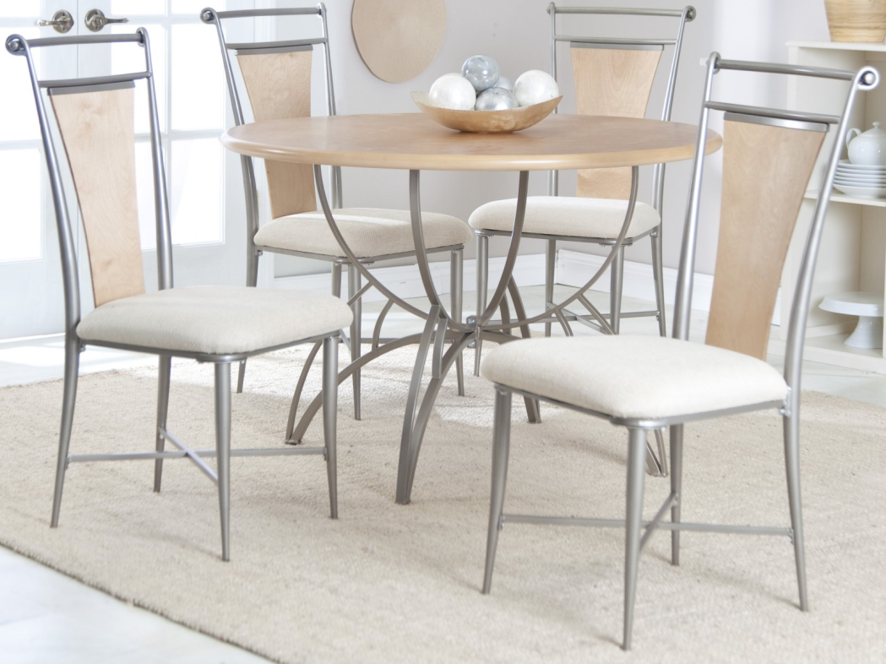

|  |
| --- |
| **DESCRIPTION** |
| LEXINGTON introduces stylish formed Seated dining set with a rich metallic finish the set of tables and chairs is perfect to create the perfect look for family gathering. The rich stainless steel with form on top gives you feeling of happiness. Perfect for you and your family. The wooden disk table made from Formica helps to establish a relationship between the complete set. |

|  |  |  |
| --- | --- | --- |
| **Price** | **1350$** | |
| **Dimensions** | **Table H** x **D** x **L** | **32in x 16in x 32in** |
| **Chairs H** x **W** x **L** | **16in x 14in x 15in** |
| **Features** | **Four Chairs and One Table with form on top prove to give you complete comfort and relaxes your entire body reduces back problems.** | |
| **Finished** | **Polished Silver** | |
| **Available in** | **Silver and White** | |